Operation Instructions for X20 Intelligent Ultrasonic lace machine

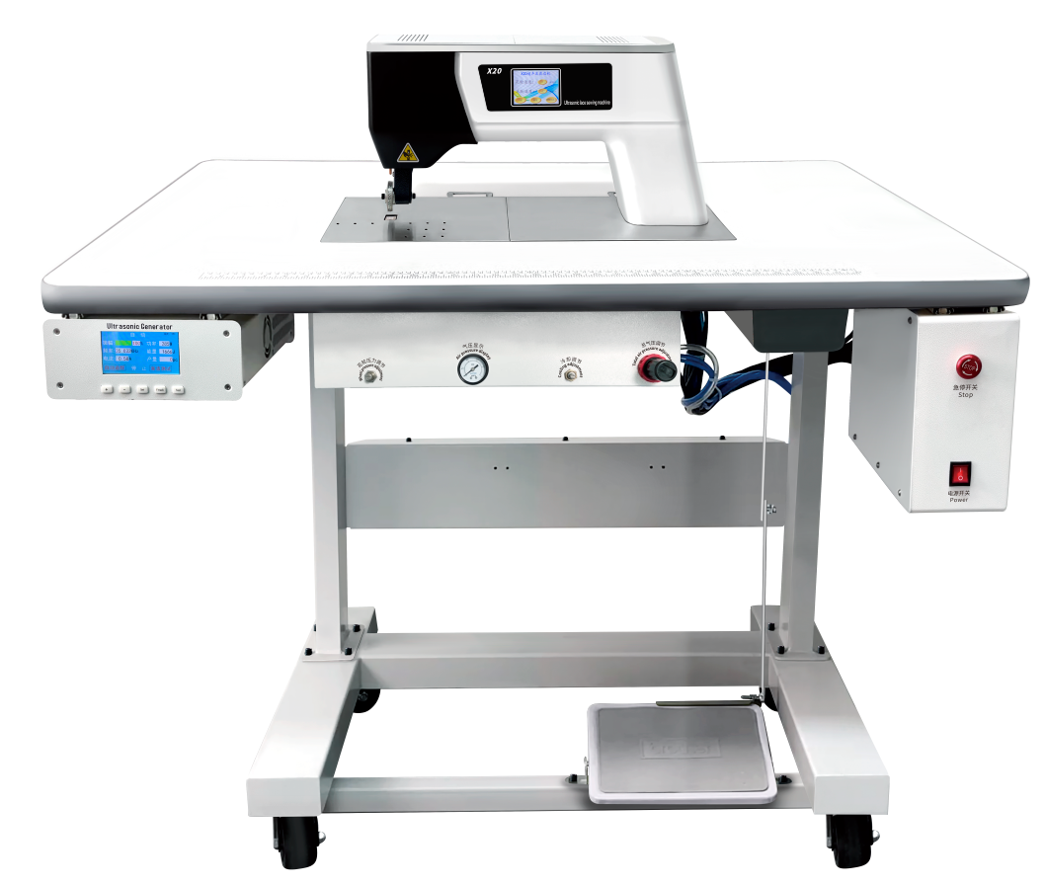

Table of Contents
- Introduction .............................................................................................................................3
- List..........................................................................................................................................3
- An Introduction to Overall Unit of X20 Ultrasonic lace machine........................................4
- Detailed Description of the Ultrasonic lace machine...........................................................5
- Basic principles.............................................................................................................5
- Key technical indicators................................................................................................5
- Installation and Commissioning Test....................................................................................6
- Power on and gas source Connection...........................................................................6
- Mounting the flower wheel...........................................................................................7
- Operation Instructions for the Touch Screen of the Ultrasonic Generator...................8
- Operation Instructions for Ultrasonic lace machine’s Touch Screen...........................8
- Way for regulating flower wheel’s pressure.................................................................9
- Way for Equipment Application and Operation...........................................................9
- Maintenance and Care.........................................................................................................10
- Simple Troubleshooting....................................................................................................10
- Cautions...........................................................................................................................11
- Quality assurance...............................................................................................................11
- Additional Explanation........................................................................................................11
Notice for use.............................................................................................................................13

I. Introduction
Dear Users,
Thank you for having purchased X series of ultrasonic lace machine equipment from Jiayuanda Technology. It is a model of intelligent ultrasonic lace machine after years of research and development by our Company. Perfect digital man-machine interface interaction is used for this series of products with steady and intelligent operation.
Before you use the equipment, please read the operation instructions carefully so that you can use it safely and quickly.
Professional or non-professional technical personnel without having received our Company’s training or authorization are not allowed to dismantle or maintain this product without authorization; any equipment failure, faults or irreversible damage caused by breach of operation rules or any safety accident will not be covered by the warranty, with any accident and/or loss so incurred will be irrelevant to our Company.
II. List
No. | Description | Quantity | Unit | Remarks
1 | X20 machine | 1 | Set | Including ultrasonic generators, hand-pieces and electric boxes as three modules
2 | 4# hex wrench | 1 | Piece
3 | Exquisite oiler | 1 | Piece
4 | Operation instructions | 1 | Copy
5 | Warranty card | 1 | Copy
III. An Introduction to Overall Unit of X20 Ultrasonic lace machine
Front:
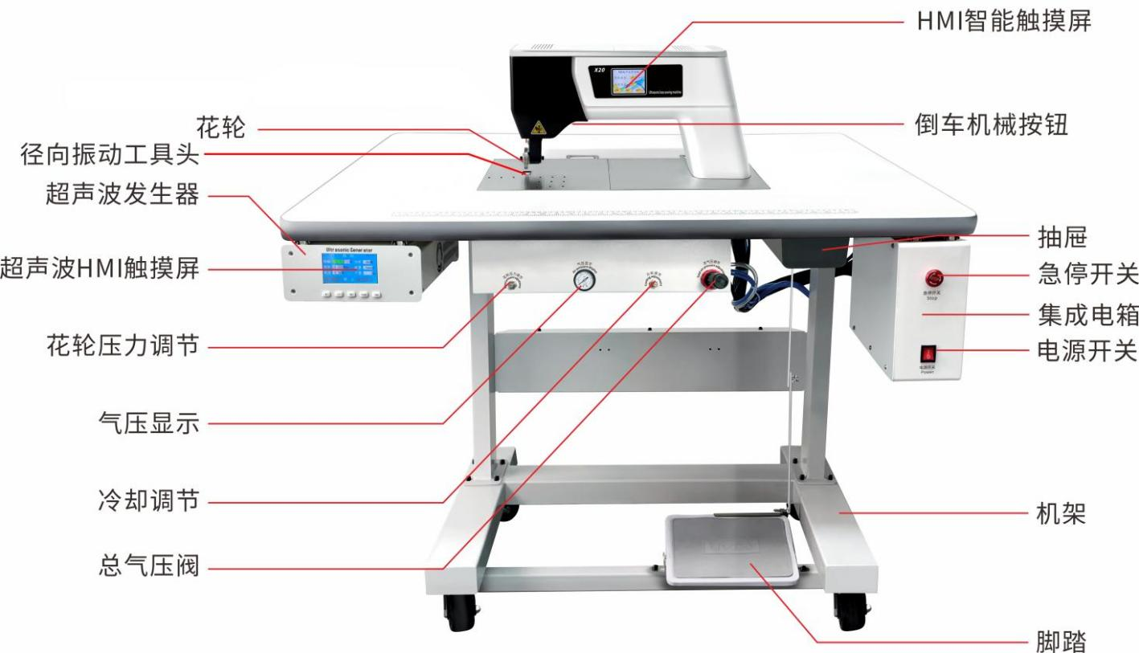
Drawer
Emergency stop switch
Integrated electric box
Power switch
Rack
Pedal
Reversing mechanical button
HMI smart touch screen
General air pressure valve
Cooling adjustment
Air pressure display

Flower wheel pressure regulation
Ultrasonic HMI touch screen
Ultrasonic generator
Flower wheel
Radial vibration tool headl

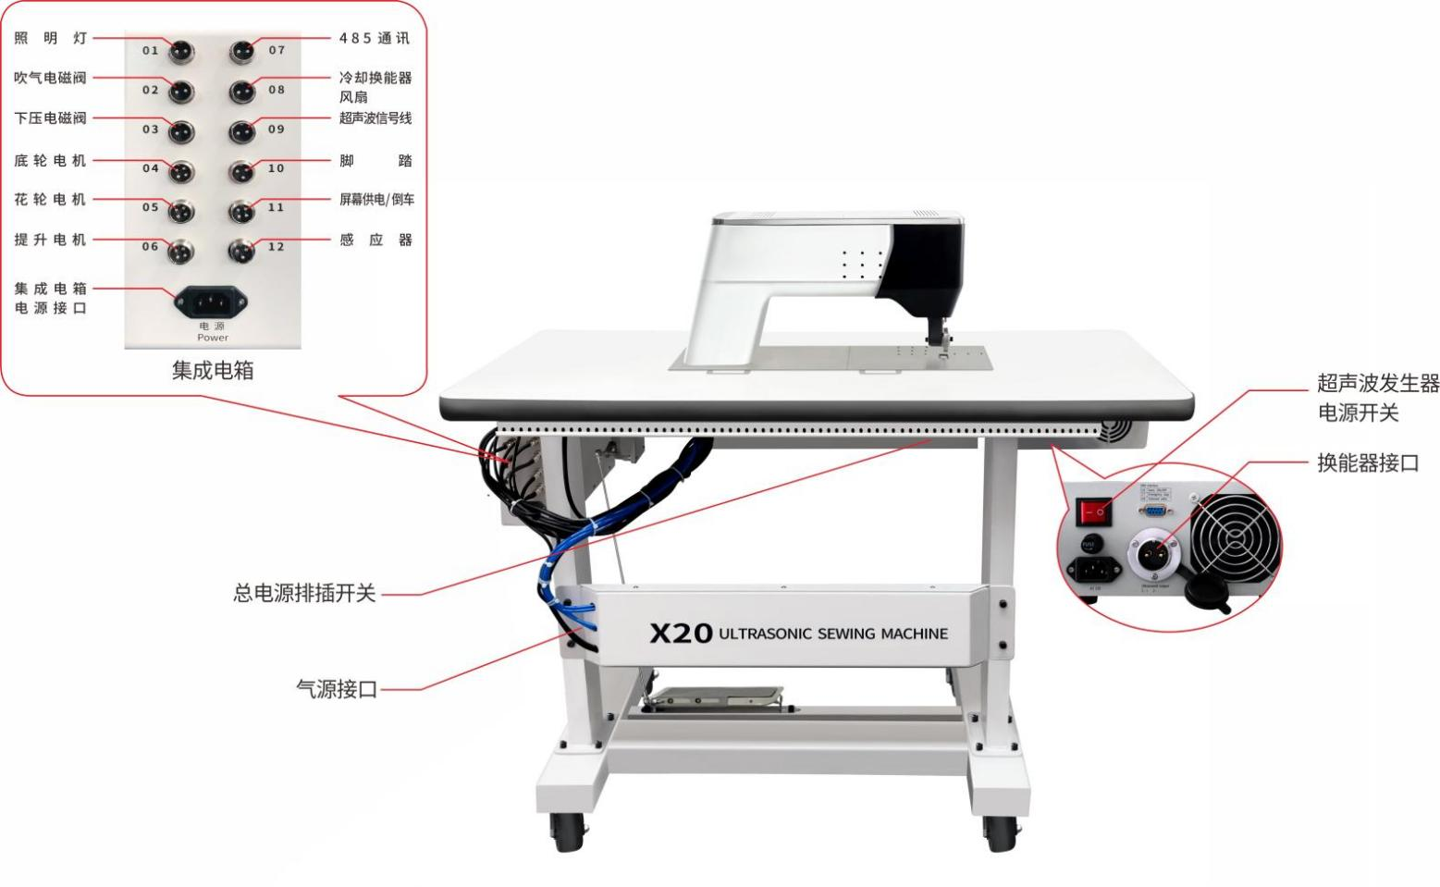
Back:
485 communication
Lighting lamp
Energy converted
interface

Power switch of
ultrasonic generator
Gas source interface supply
Socket switch of general power supply
Integrated electric box
Sensor
Screen power supply/reversing
Pedal
Ultrasonic signal wire
Cooling transducer fan
Integrated electric box
power interface
Lifting motor
Flower wheel motor
Bottom wheel motor
Press-down solenoid valve

Air blow solenoid valve
IV. Detailed Description of the Ultrasonic lace machine
1. Basic principles
This unit generates ultrasonic wave by its ultrasonic generator, and generates radial vibration via its energy exchange device, and the vibration amplitude is amplified by means of amplitude changing rod; the motor drives the luffing rod and the flower wheel back rotation respectively. When the flower wheel is pressed down and contacts the working surface of the luffing rod, the fabric between the flower wheel and the luffing rod can be cut and melted under the mechanical effect of ultrasonic (radial vibration) and thermal effect. The press wheel drives the fabric to slide away from the work table to achieve the function of continuous cutting and printing.

- Key technical indicators
Power supply: AC 220-250V 50-60Hz
gas source: 0.4Mpa
Maximum power consumption: 600W -1000W
Operating frequency: 35KHz±0.3KHz
Operating speed: 4.0 - 40m/min
Lace width: 1-15mm
Fabric thickness: 0.1-3mm
Total power (max) : 1200W

V. Installation and Commissioning Test
1. Power on and gas source Connection
Plug the power cord into the AC power supply of 220 V (AC), turn on the ultrasonic power switch (Figure 1) and the power supply of the electric box machine (Figure 2), and wait for the ultrasonic touch screen (Figure 3) and the lace machine touch screen (Figure 4) as shown in the figure.
Insert the external gas source directly into the reserved air pipe joint of the lace machine with an 8mm air pipe (Figure 5). The external gas source is about 0.5MPa, and adjust the total air pressure regulating valve of the lace machine to the pressure corresponding to the cloth thickness (generally 0.4MPa).
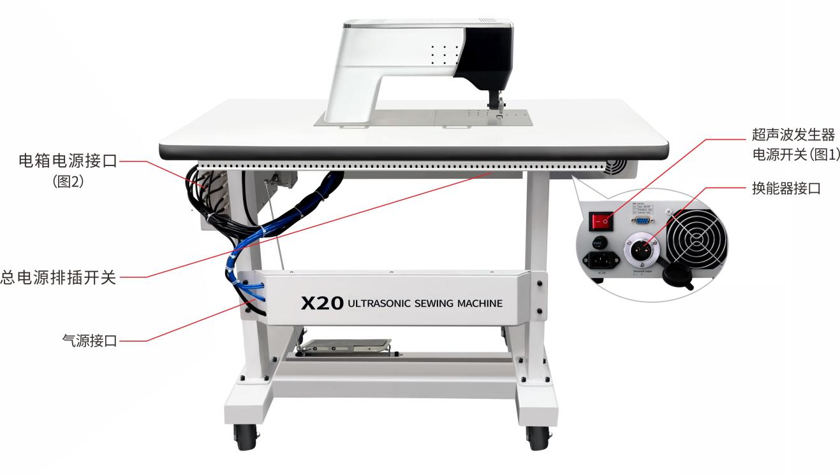
Power interface of electric box (Figure 2)
Energy converted interface
Power switch of
ultrasonic generator
(Figure 1)
Gas source interface supply
Socket switch of general power supply

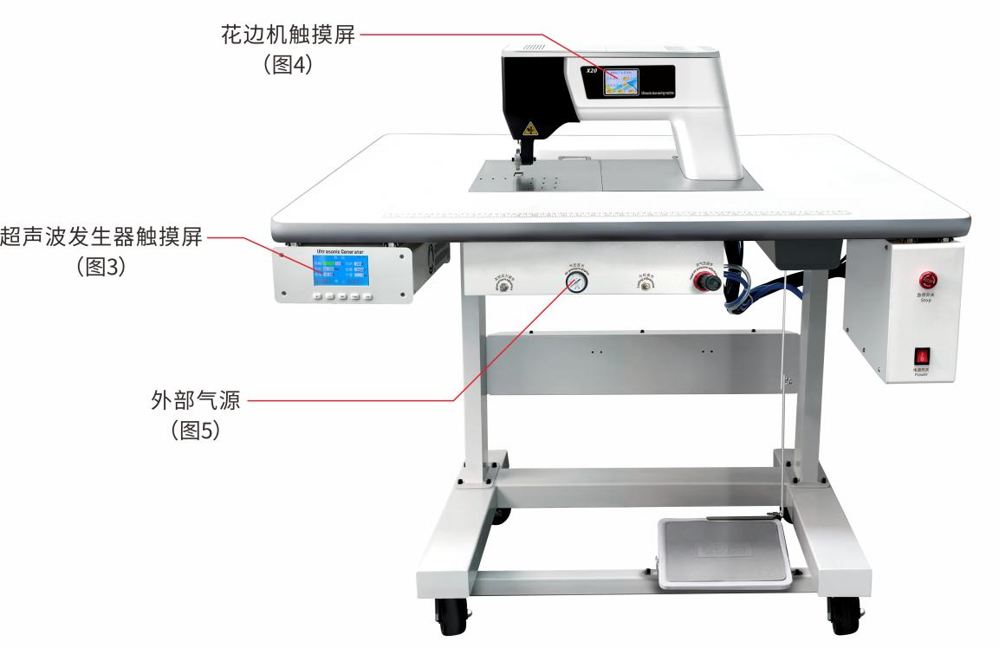
External gas source
(Figure 5)

Ultrasonic generator’s touch screen (Figure 3)
Touch screen of lace machine (Figure 4)

2. Mounting the flower wheel
When it becomes normal after power on, press the emergency stop button,. and the lace machine will lift automatically to facilitate the exchange of the flower wheel.
After the emergency stop button is pressed, the machine automatically lifts its height. Release the flower wheel’s screw to remove the current flower wheel and change it into the required flower wheel. Tighten the screw, turn the emergency stop to restore to the initial state. That is the end of flower wheel exchange (as shown in the figure below).
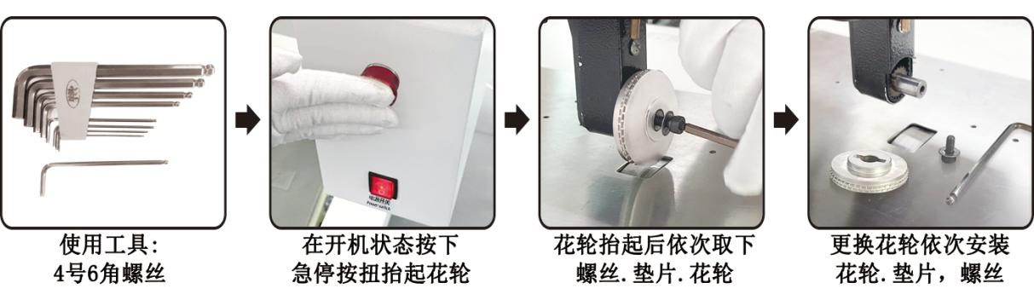
Change the flower wheel, and mount the flower wheel, shim and screw in turn
After the flower wheel is lifted, remove the screw, shim and flower wheel in turn
In the power on state, press the emergency stop button to lift the flower wheel
Tool used: 4# hex screw

Operation steps

- Operation Instructions for the Touch Screen of the Ultrasonic Generator
3.1 Operation Instructions for Automatic Frequency Tracing by the Ultrasonic Generator
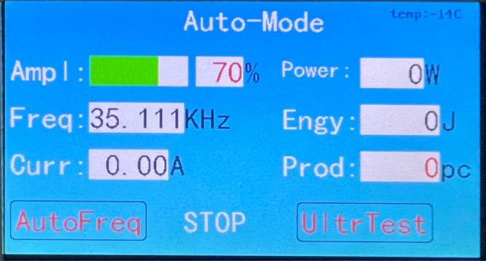
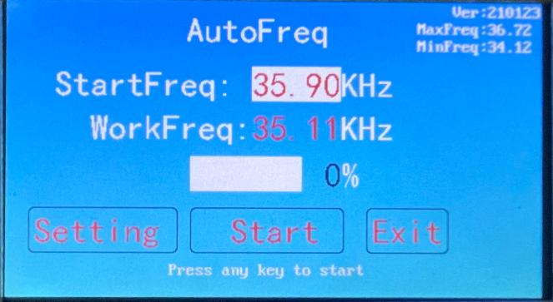

第二步: 按“开始”键即可开始追频。
第一步: 启动发生器电源 (即显示如上图)
按“自动追频”键；

Step 1: Activate the power supply for the generator (namely, as shown in the figure above). Press the "Auto Frequency Tracing" button;
Step 2: Press the "Start" button to be able to start frequency tracing.

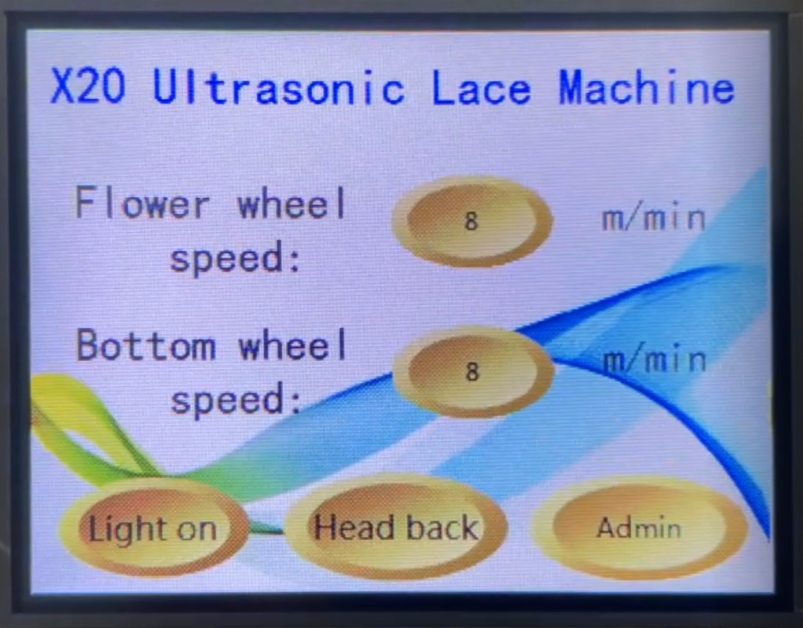
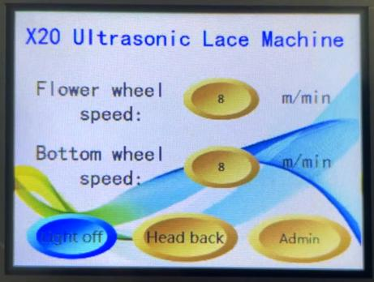
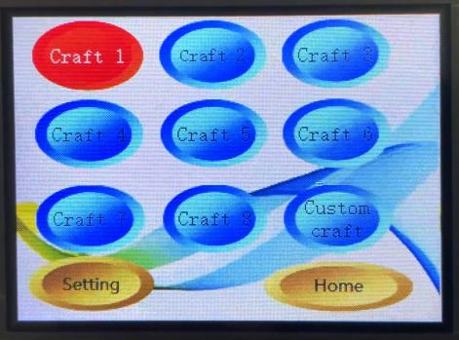
4. Operation Instructions for Ultrasonic lace machine’s Touch Screen
Step 3: Press the “Manager access” button from the interface to be able to perform various ‘process’ settings. If it is required to set “Process 1”, click on the “Parameter Settings” to be able to enter the parameter setting;

Step 2: Make selection as you require. For example: press the “lamp on” button, and the light at the flower wheel will be on. If the lamp is to be switched off, press the “lamp off”; the same with the operation of “forward” function;

Step 1: Chinese and English interface;

Back

第五

步
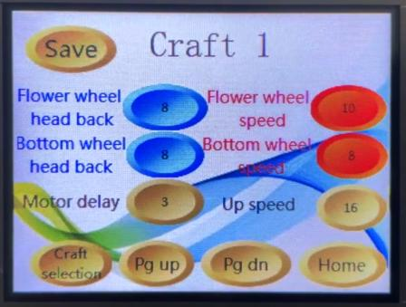 | 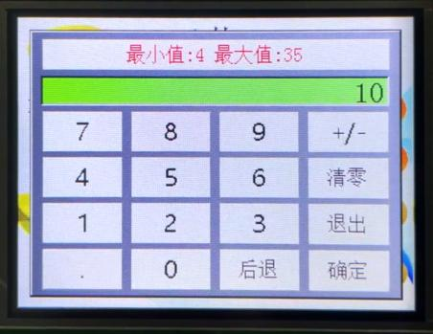  Back  Quit  Clear  OK  Minimum value: 4 Maximum value: 35 | 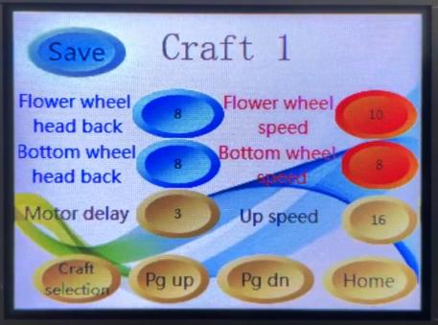
Step 4: Select the set data as you require  For example, click on “flower wheel speed”to enter the interface at Step 5; | Step 5: Set corresponding parameters as required; | Step 6: Click on "Save" in the left upper corner to finish parameter settings (the same way for parameter setting in other processes).
也需要翻译
5. Way for regulating flower wheel’s pressure
The adjustment to the flower wheel’s pressure depends on the material and thickness of fabric. Generally, the thicker fabric with lower chemical fiber requires greater pressure.
Turn the cylinder knob at the lower part of the rotation table, and adjust it to a suitable pressure according to the thickness of the sewed materials (0.5Mpa as recommended)
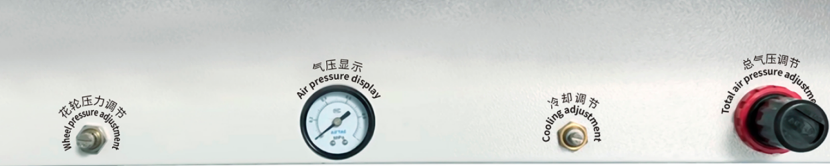
- Way for Equipment Application and Operation
- Step on the pedal backward, and the flower wheel will lift up automatically. Then place the processed material under the flower wheel (Never put hands under it to avoid injury by pressing!!!);
- Release the pedal (In the original state, the flower wheel presses fabric automatically);
- Set the pedal forward stepping as forward movement as the default. If it requires reversing, click on the “Reversing (as shown in the figure below) or reversing mechanical button (see Page 4) on the screen to finish reversing and forward operation switching;

- When the lamp is dim, you can click on the screen lamp on for lighting;
- Way for releasing the emergency stop switch: If the emergency stop switch is pressed, manually hold the “Emergency Stop Switch”, and turn it right until it pops up automatically.
VI. Maintenance and Care
1. Regularly add lubricants to the flower wheel’s turning shaft, synchronous belt’s shaft, radial vibration rotary bearing, motor’s coupling bearing and other friction parts (※Note: during lubricant addition, power supply must be disconnected).
2. Regularly clear debris off the bottom radial vibration cooling fan to prevent fan block to cause poor heat dissipation (※Note: Power supply must be disconnected at the time of waste clearance).
3. Regularly clear wastes such as bottom radial vibration debris (※Note: Power supply must be disconnected at the time of waste clearance).

VII. Simple Troubleshooting
1. What if the ultrasonic lace machine is not firmly welded or fails to be welded?
Answer: a. Check whether the air pressure is 0.4Mpa;
- The screen is not on after powered on?
Answer: Check whether the power cord is properly inserted, and whether it is AC 220V voltage.
- The motor fails to turn or is jammed?
Answer: a. Check whether the emergency stop switch is released;
b. Check whether the flower wheel is stuck without lubricants. Remove the flower wheel, add corresponding lubricants and restart.
- No reaction after front and rear stepping?
Answer: a. Check whether the emergency stop is released;
b. Check whether the air pressure meter has air pressure;
c. Whether there is value in the process parameter.
- There is turning but no welding after the the pedal flower wheel is stepped on?
Answer: a. Check whether the ultrasonic wave sends out waves. Click on automatic frequency tracing again;
b. Check whether the air pressure has 0.4Mpa air pressure, and whether the air pressure switch is on;
c. Adjust the hard limit at the lower port of the mainframe to a proper position.

VIII. Cautions
1. When started, the cover of ultrasonic vibrator shall not be opened to avoid high pressure injury or damage to the machine.
2. The machine must be grounded reliably.
3. When the ultrasonic generator is working, there shall be no open circuit at the output end.
4. When the ultrasonic generator is working, the ammeter indicates more than 2a, and is accompanied by insufficient power (the phenomenon is no edge cut and no perforation), the power shall be turned off immediately, and the operation can be started after the cause of the fault is detected.
5. The continuous working duration of the machine shall be 8 hours.
6. When the machine lies idle, loosen the pressure wheel, cut off the gas source and loosen the flower wheel.
7. The machine must be maintained by special personnel.
8. The luffing rod, motor and foot switch are vulnerable parts, which are not covered by the warranty.
IX. Quality assurance
Quality guarantee for this product shall be subject to the following regulations:

The overall unit is subject to 12 months’ warranty (based on natural days), except vulnerable parts!

Vulnerable parts include: tool heads subject to warranty for 3 months, with no warranty for the flower wheel (as the flower wheel is a consumable material).

Faults caused by the following reasons belong to paid repair, even within the period warranty:
- Irreversible failure and accident caused by improper operation or unauthorized repair;
- Problems caused by using beyond requirements in standards and specifications;
- Damage caused by falling or rude handling after purchase;
- Component aging or fault caused by using in environment not meeting requirements in the Manual;
- Equipment damage caused by foreign matters entering outside (such as insect);
- Equipment damage caused by wiring error;
- Faults caused by earthquake, fire, geomantic disaster, lightning strike, abnormal voltage or other natural disasters and causes accompanying with disasters.

The Company is entitled to entrust others for repair for products involved in faults.

If it is indeed covered by the warranty in the case of liability on the part of this Company:
- Warranty within 12 months after delivery making (with vulnerable parts beyond the warranty).
Ⅹ. Additional Explanation
About disclaimer:
- This Company will not assume the liability arising or derived from the use of this product due to breach of requirements set out in this User’s Manual;
- The Company does not undertake responsibility for compensation against losses or impacted and secondary damages caused to you by faults of the product.

Notice for use:
Although the product is designed and manufactured under strict quality control, please be sure to ask us about using purposes where its fault or mis-operation may endanger human body or other lives.

- The flower wheel supports customization, with specific flower wheels depending on the difficulty or easiness of the patterns of the flower wheels.

Contact Us

Hotline: +（86）769-83506468
Website: www.jydultrasonicmachine.com

※ This Company reserves the right to revise this Manual without prior notice; the right in final interpretation will be vested in the Company. If you have any doubt or question, please contact us in a timely manner. Welcome to propose improvement comments.

